ODS Sub ICB Coding for London

Problems & Impacts Leading to ICB Proxy & Sub-ICB Reporting Entities (SI-RE) Proposal (Feb’24)

This paper relates to requests received by ODS for meaningful sub-ICB level codes for London via the ODS Service Desk. This is the ODS BAU process for code requests, changes and closures; the Service Desk deals with around 950 such front line request each month.

|  |  |  |  |
| --- | --- | --- | --- |
| Document filename: | **BAU London - ICB Proxy & Sub-ICB Reporting Entities v2.0** | | |
| Project / Programme | **ODS Business As Usual** | Project | **Business As Usual** |
| Project Manager | **Not Required** | Status | **Issued** |
| Owner | **Mark Dye** | Version | **2.0** |
| Author | **Kana Kanagendra** | Version issue date | **14/02/2024** |

Contributors & Reviewers

This following individuals contributed and reviewed the contents of this document:

|  |  |  |
| --- | --- | --- |
| Name | Title / Responsibility | Organisation |
| Ian Raisbeck-Blades | Primary Care Manager (OC1) | NHS South West London ICB |
| Yashoda Patel | Performance and Delivery Lead - Learning Disability & Autism Prog. | NHSE London Region |
| Charlotte Green | Deputy Programme Manager - MH | NHSE London Region |
| Sara Rosenquist | Programme Lead – MH Dashboards | NHS South East London ICB |
| Laura Reeves | Senior Business Analyst | ODS, TSAS NHSE |
| Stephen Pearson | Senior Analytical Lead | PAT, NHSE London Region |
| Angus Steele | Former Senior Programme Lead – London CCG Mergers | NHSE London Region |
| Dr Payam Torabi | Clinical Lead for Population Health and Health Inequalities, | NHS North East London ICB |
| Rachel McIlroy | Senior Programme Lead – System Intelligence | System Transformation Team, CDOD NHSE |

Approved by

This document must be approved by the following individual(s):

|  |  |  |  |
| --- | --- | --- | --- |
| Name | Title | Date | Version |
| Gill Foley | Data and Clinical Content Standards Lead | 15-Jan-24 | 1.0 |
| Mark Dye | Senior Programme Mgr, ODS | 9-Jan-24 | 1.0 |

**Change History**

|  |  |  |
| --- | --- | --- |
| **Ver** | **Change** | **Author** |
| 2 | Reflect change to solution following initial alpha trial version of changes and feedback from NEL CSU data team (Laura, Mark B, W.Wood) | Kana |

Contents

1. Background 3

2. ODS BAU Service Challenge 3

3. Problem 1: Loss of Relevant Data Granularity 3

3.1. Impact of Problem 1 3

3.1.1. Loss of Relevant Data for Planning 3

3.1.2. Micro-Commissioning Challenges & Potential IG Breaches 4

3.1.3. Additional Workload 4

3.1.4. Inaccurate Reporting on National Dashboards 4

3.1.5. Inconsistent Apportionment of Data 5

4. Problem 2: Inequality 5

4.1. Impact of Problem 2 5

4.1.1. Inability to Identify Inequalities of Service 5

4.1.2. Inconsistent Reference Data 5

5. Problem 3: Appropriate System Access 5

5.1. Impact of Problem 3 - Inefficiency 6

6. Recommendations 6

6.1. ICB Commissioning Proxy 6

6.2. Sub-ICB Reporting Entity (SI-RE) 6

6.3. Transition to Possible *Place* Coding 7

6.4. Communication & Preparation 7

6.5. Impact of not implementing the recommendations 8

7. Appendix A: Example of National Dashboard Using sub ICB Codes 8

7.1. PaPI Dashboard for London ICB With 2.4 Million Population 8

7.2. PaPI Dashboard for Humber & North Yorkshire ICB With 1.8 Million Population 8

8. Appendix B: Changes to ODS Data 9

8.1. Current Model 9

8.2. Interim Solution for 5 London ICBs – Part 1: ICB Commissioning Proxy 9

8.3. Interim Solution for 5 London ICBs – Part 2: Sub-ICB Reporting Entities 10

Background

Prior to the Health and Care Act (2022) CCGs were encouraged by NHS England to merge in preparation for becoming ICBs. Many (but not all) CCGs did this, including all those in London. ODS was asked to support this and issued new codes for these merged CCGs and closed the codes for the legacy CCGs in 2020. GP practices and PCNs were reconfigured to show these new merged CCG codes as their commissioner. The number of CCGs reduced from 152 to 106 across England and from 32 to 5 in London.

In July 2022, ICB codes were introduced and CCGs codes became ‘sub ICB locations’ codes. As a result of the CCG mergers, each of the 5 London ICBs had only one ‘sub ICB location’ code which was co-terminous with the ICB, i.e. there is no granularity available at the lower tier.

ODS BAU Service Challenge

Prior to the mergers, the CCGs in London were largely aligned with the London Boroughs. Shortly after the merger, London noted that they had lost access to Borough-level data[1] on their populations, as an unintended consequence of merging CCGs. This was raised in a paper written by the project lead (Angus Steele) in October 2020.

Since July 2022, ODS has received at least 4 service requests and one direct escalation to reinstate meaningful, Borough related codes at the sub-ICB level for London ICBs to address service problems, showing the problem has not resolved itself:

* Jan-24: North East London ICB (SCTASK0137029)
* Nov-23: South West London ICB (SCTASK0119033)
* Oct-23: London Region Learning Disability & Autism Team (SCTASK0113075)
* Sep-22: Performance Analysis team in London (SCTASK0028991)
* North Central London ICB were going to request raise a request but have refrained due to knowledge of this paper.

Problem 1: Loss of Relevant Data Granularity

It became clear that ODS codes were a critical infrastructure element that allowed systems to access key datasets at an ex-CCG/Borough level. While some datasets have workarounds using other geographical proxies (e.g. postal code), many do not and rely on ODS codes as the most granular way to analyse data (see Appendix).

* 1. Impact of Problem 1
     1. Loss of Relevant Data for Planning

London ICBs can no longer access key data at a level that supports meaningful planning of services and addressing equity at a Borough level with their LA partners. Affected datasets include mental health services, out-of-area placements, cancer services, childhood obesity, learning disabilities, Referral-to-Treatment, Continuing Healhcare, specialised commissioned services and Primary Care Insights.

* South East London (SEL) ICS was previously able to view diagnostic and cancer waiting times for each of its Boroughs. They can now only see aggregated waiting times for all of SEL ICS i.e. across 1.9 million people.
* The following national dashboards and [NHS England applications](https://apps.model.nhs.uk/a-z) are unable to allow drill down to ex-CCG based information for ICBs to share with their statutory LA partners:
* Primary Care Data and Insights Dashboard (PCDID – Foundry/FDP)
* GP Practice Workforce interactive dashboard
* Appointments in General Practice dashboard
* Urgent Community Response (UCR) dashboard
* Population and Person Insights (PaPI) Dashboard

The PaPI team received an email in January 2024 from the Clinical Lead for Population Health and Health Inequalities, NHS North East London ICB stating:

*“I was wondering if for ICBs like my own (NEL ICB) we could have data presented by place (e.g., old CCG areas like Newham, Redbridge, Tower Hamlets) as so much delivery happens at place level and the lack of data at this level is a substantial barrier to use of this tool.”* (see Appendix).

Much of transformation work requires a view at a Borough level particularly as we approach the end of the 5 year long-term programmes.  Without meaningful sub-ICB codes, ICBs are unable to do the grouping or the longitudinal analysis to show the impact of existing transformation programmes using current analytical products and data flows for mental health, primary care, community services, Assuring Transformation and Acute (outpatient, inpatient care, emergency care). Analysis and improvement conversations become more generic as ICBs are unable to see what is happening at a Borough level and undercut their ability to ensure equity.

* + 1. Micro-Commissioning Challenges & Potential IG Breaches

It is also having a detrimental impact in micro-commissioning where allocation of patients to the old, Borough based CCG boundaries is still in place, however now ICBs are unable to allocate new patients to a sub-ICB geography on the clinical audit platforms and National Case Management system. This affects services like Continuing Health Care, Assuring Transformation – Learning disability and autism inpatients and Specialised commissioning services. This means:

* they cannot address where care is failing as they are unable to see which Borough-based commissioner is responsible for the patient.
* ICBs have to run a separate list in Excel with patient identifiable information to manage the patient - creating a significant potential for information governance breaches.
  + 1. Additional Workload
* South East London (SEL) ICB had 2.5 Business Intelligence staff working for 9 months to build a workaround for mental health planning due to a lack of sub-ICB codes.
* South West London (SWL) ICB - *"Whenever we receive data files from various NHS organisations or systems, we must always retro-add the Borough layer, which we believe should be the Sub-ICB level, to make the data useful/meaningful…adds 30+ minutes for each"*
* The London performance analysis team (PAT) have to recreate national dashboards at a borough level for these to be useful for their ICB. No view of the additional time taken was available as various members of team do different dashboards.
  + 1. Inaccurate Reporting on National Dashboards
* Providers are set targets by ICBs but performance against this is not reflected on national dashboards if they also serve patients from a Borough in a different ICB – Croydon Health Services NHS Trust for SWL ICB and SEL ICB.
  + 1. Inconsistent Apportionment of Data
* London Mental Health Regional team - “*The lack of meaningful sub-ICB codes means that local BI teams are apportioning the data based on previous GP to CCG logic which will then be updated locally, creating 2 version of the geographic profile of London at a granular level*.”

Problem 2: Inequality

When the 2022 Act was introduced, the 106 CCGs were made into sub ICB locations (SICBL) of the 42 ICBs. However, because of the CCG mergers prior to this, a ‘mixed economy’ arose:

* 26 ICBs have only one sub ICB location i.e. it is coterminous with the ICB so there is no granularity, and the term “sub ICB” is a misnomer.
* 16 ICBs which did not merge their CCGs have multiple sub ICB locations i.e. they have granularity below the ICB level.

A precedent for using these multiple sub ICB location codes as a ‘place’ marker for planning and reporting has already been set by:

* Humber & North Yorkshire – moved14 GP practices between sub-ICB locations to align the two sub-ICB location codes to LAs (first requested September 2022)
* SNEE – realigned GP practices and are now requesting some geography changes (service ticket pending – issue raised via ONS in November 2023)
  1. Impact of Problem 2
     1. Inability to Identify Inequalities of Service

There is frustration as London are at a disadvantage compared to other regions where colleagues have multiple sub-ICBs that map to unmerged CCG. In an email to ODS in July 2023, the London Mental Health Regional team said:

*“This makes it difficult for us in the London region and our ICB colleagues to look where there may be discrepancies in their patches as we cannot get the granularity we require to truly understand service activity across our region. In other regions, the sub-ICB codes align with the previous CCG codes which increases frustration as we are not able to target support and focus when compared to them”.*

Planning is done based on needs and they are unable to say if the mental health needs of various Boroughs was being addressed, particularly as there are vast differences between Boroughs within the same ICB.

* + 1. Inconsistent Reference Data

The data warehouses that underpin analytical products use the ODS reference tables (see Appendix).  If the data teams do not have ODS reference tables at meaningful sub-ICB level for London then the data teams create their own.  There will then be multiple versions of mapping tables as there is no process to manage this at a London level. The view of the London regional teams is that it is neither feasible nor wise to create a separate process outside of the ODS.

Problem 3: Appropriate System Access

On CQRS National and Local, PCSE Online and on other systems users are unable to *easily* access the *appropriate* areas. This could mean that inappropriate access needs to be granted to overcome the access issues or set up alternative mechanisms.

* 1. Impact of Problem 3 - Inefficiency

Every query about claims or payments received by South West London ICB requires them to use a separate spreadsheet to identify the Borough so that the query can be referred to the appropriate commissioner for the Borough within the ICB. This adds 15 minutes to the process.

# Recommendations

Implement two ODS data changes to help London from April 2024 (see Appendix B for diagrams related to these changes):

* 1. ICB Commissioning Proxy

For the 5 current London sub ICB Location codes - 36L, A3A8R, 72Q, W2U3Z and 93C:

1. The primary role (organisation type) of Clinical Commissioning Group [role code RO96] will remain.
2. The non-primary role of sub ICB Location [role code RO319] will remain.
3. Add a new, non-primary role of “ICB Commissioning Proxy” [role code tbc].
4. These codes will continue to hold the current commissioning relationship to GP practices, PCNs etc.
   1. This is used in many other applications e.g. SPINE, SUS+, RA (CIS/Smartcard), etc, so we will not risk breaking those.
5. No changes to the names of these codes – they will still have the nationally agreed name format (e.g. NHS NORTH EAST LONDON ICB – A3A8R) as used in NHSmail containers.
6. The relationship to the ICB remains unchanged as “In the Geography of” [RE5].

The codes, names and the primary role/organisation type (CCG) used to identify the ‘commissioner’ would remain unchanged. Therefore, we would envisage low impact to dependent systems and processes.

* 1. Sub-ICB Reporting Entity (SI-RE)

Introduce a new non-primary role of “Sub-ICB Reporting Entity” (SI-RE) [role code tbc] within the Clinical Commissioning Group primary role [role code RO96].

1. Issue 32 new SI-RE codes for each Borough or pre-merger CCG in London.
   1. Name these SI-RE codes based on the Borough-based partnerships as listed on page 7 of the 5Ps inPLACE Framework [[5Ps-inPLACE-Framework-and-Toolkit-v.6-October-2022.pdf (transformationpartners.nhs.uk)](https://www.transformationpartners.nhs.uk/wp-content/uploads/2023/01/5Ps-inPLACE-Framework-and-Toolkit-v.6-October-2022.pdf)] or amended at the request of the OC1 for the ICB.
   2. Link these 32 new codes to the related ICB/ICS as shown in the above list of Borough-based partnerships using the relationship “Is Sub-Division Of” [RE2].
   3. The address and postcode of the SI-RE will be that of the parent ICB.
2. Link the appropriate Prescribing Cost Centres [role code RO177] including GP Practices [role code RO76] to the relevant Sub ICB Reporting Entity (SI-RE):
   1. Introduce a new relationship type “Is constituent of” [RE tbc] for this link.
   2. Determine the relevant SI-RE by remapping Prescribing Cost Centre data to predecessor (pre-merger) CCGs to provide an initial list and supplement it with suggestions for newer Prescribing Cost Centres using NHS Postcode data. This will then be confirmed by the OC1s for each ICB.
   3. Allows end-users to exclude non-relevant Prescribing Cost Centre to see just GP practices [role code RO76] by filtering on the non-primary role codes.
   4. We have been requested to define these Sub-ICB Reporting Entities (SI-RE) using Prescribing Cost Centres, particularly GP Practices as this is the ‘lowest common denominator’ that the ICBs and London Regional teams need for their operational requirements.
3. GP practices in London will then have at least 3 relationships:
   1. “Commissioned by” [RE4] relationship to the ICB Commissioning Proxy / sub ICB Location code.
   2. “Is Partner to” [RE8] or “Is Nominated Payee for” [RE9] relationship to one Primary Care Network (PCN) code.
   3. “Is Constituent of” [RE tbc] relationship to one Sub-ICB Reporting Entity (SI-RE) code [RO tbc].
4. These Prescribing Cost Centre (including GP Practice) to SI-RE relationships will be published via the ODS API from 1 April 2024 and should become available on the new ODS – Data Search & Export (ODS-DSE) tool in July 2024 when the tool is scheduled to go live in a beta version. These relationships will **not** be available in the csv file epracur or on the current ODS Portal or ODS DataPoint tool.

Therefore, London will have 37 codes, all under the primary role of ‘Clinical Commissioning Group’ [RO98], but with different Non-Primary Roles indicating their different functions and purposes.

* 5 existing ones - 36L, A3A8R, 72Q, W2U3Z and 93C - with the ICB name and code at the end (e.g. NHS SOUTH WEST LONDON ICB – 36L), with an active ‘Sub ICB Location’ non-primary role [RO319] **and** an active ‘ICB Commissioning Proxy’ non-primary role [role code tbc] – the latter indicating the presence of Sub-ICB Reporting Entities,
* 32 new codes with the name of the London Borough, with an active ‘Sub-ICB Reporting Entity’ non-primary role [RO tbc].

We envisage low impact to dependent systems and processes from these changes

* 1. Transition to Possible *Place* Coding

These changes are for **London only** and to be implemented by April 2024 as they have been pressing for these for some time. There is a wider NHSE discovery on the need for defining and possibly codifying ‘places’ and ‘neighbourhoods’. This is why this solution is referred to as an interim solution for London. Other ICBs requiring something similar will have to await the outcome and recommendations of that discovery.

It is noted that in London, ‘places’ are Boroughs based local partnerships ([5Ps-inPLACE-Framework-and-Toolkit-v.6-October-2022.pdf (transformationpartners.nhs.uk)](https://www.transformationpartners.nhs.uk/wp-content/uploads/2023/01/5Ps-inPLACE-Framework-and-Toolkit-v.6-October-2022.pdf)). We envisage that the London SI-RE codes could evolve into ‘place’ codes - **if these are agreed for national implementation**. We anticipate that the likely change will be to the roles (either primary or non-primary) related to these codes, as was done for the introduction of ICBs in July 2022. This may be accompanied by a geographic definition using ONS LSOAs, which ODS would do in the NHS Postcode Directory.

* 1. Communication & Preparation

Prior to implementing these changes follow normal ODS communications processes to:

* Check if ODS system users anticipate any issues of consuming either of the new non-primary roles – ICB Commissioning Proxy and Sub-ICB Reporting Entity (SI-RE).
* Make it clear that this is requested by London and is not a precedent that these are ‘places’ nor need to be defined as clearly for all reporting lines.
* Agree with CHC PLDS data submitters that they continue to use the defunct ex-CCG codes – as they are doing currently or want to use SI-RE codes.
* Request lists of GP practices aligned to each potential Borough based sub-ICB Reporting Entities from the ICBs – to be submitted by the OC1s of the ICBs.
  1. Impact of not implementing the recommendations
* Lack of granularity masks health inequalities e.g. if one London Borough needs more ‘bed stays’ than another, hindering delivery of priority 3 of the NHS mandate.
* Create significant potential for information governance breaches.
* Inconsistency with multiple, uncontrolled local sub-ICB reference tables.
* Ongoing costs associated with the various workarounds.

Appendix A: Example of National Dashboard Using sub ICB Codes

* 1. PaPI Dashboard for London ICB With 2.4 Million Population

* 1. PaPI Dashboard for Humber & North Yorkshire ICB With 1.8 Million Population

Uses CHC PLDS local table to provide meaningful names (ex CCG) of sub ICB locations codes

This dashboard is an example of where the PaPI team had used a local table to translate or lookup a different name for the sub ICB location code than that which is published by ODS (which is somewhat unhelpful but was requested by NHSE).

Appendix B: Changes to ODS Data

* 1. ****Current Model****

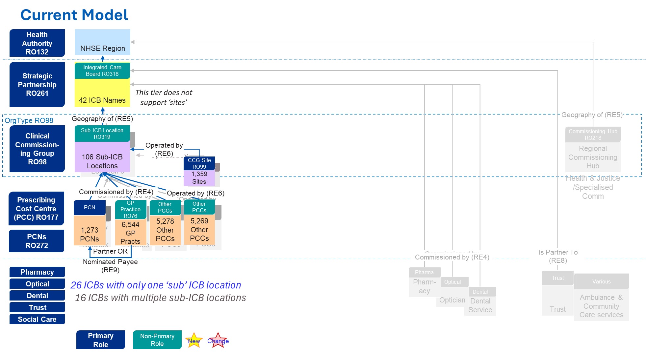

* 1. ****Interim Solution for 5 London ICBs – Part 1: ICB Commissioning Proxy****

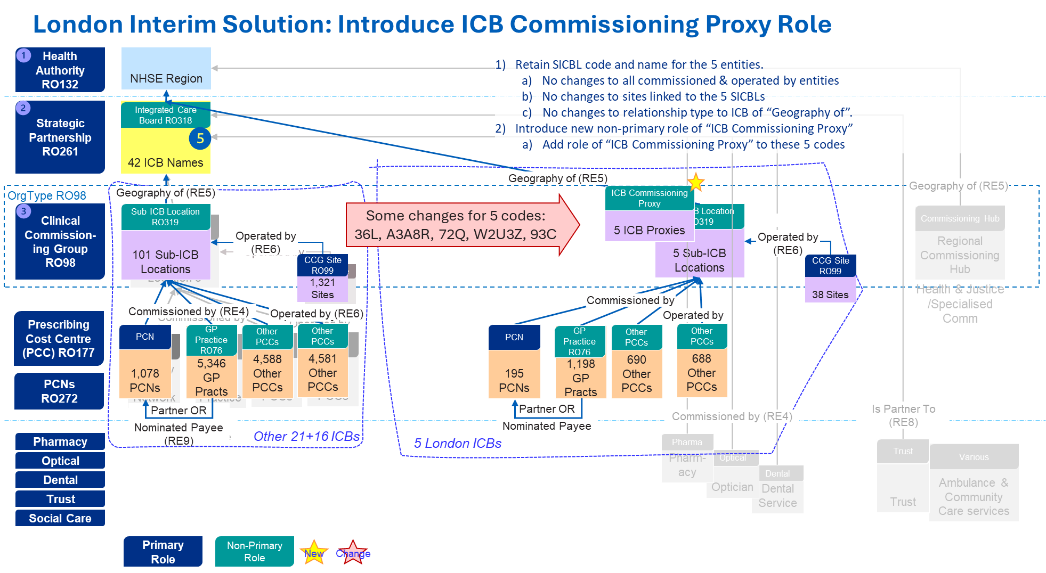

* 1. ****Interim Solution for 5 London ICBs – Part 2: Sub-ICB Reporting Entities****

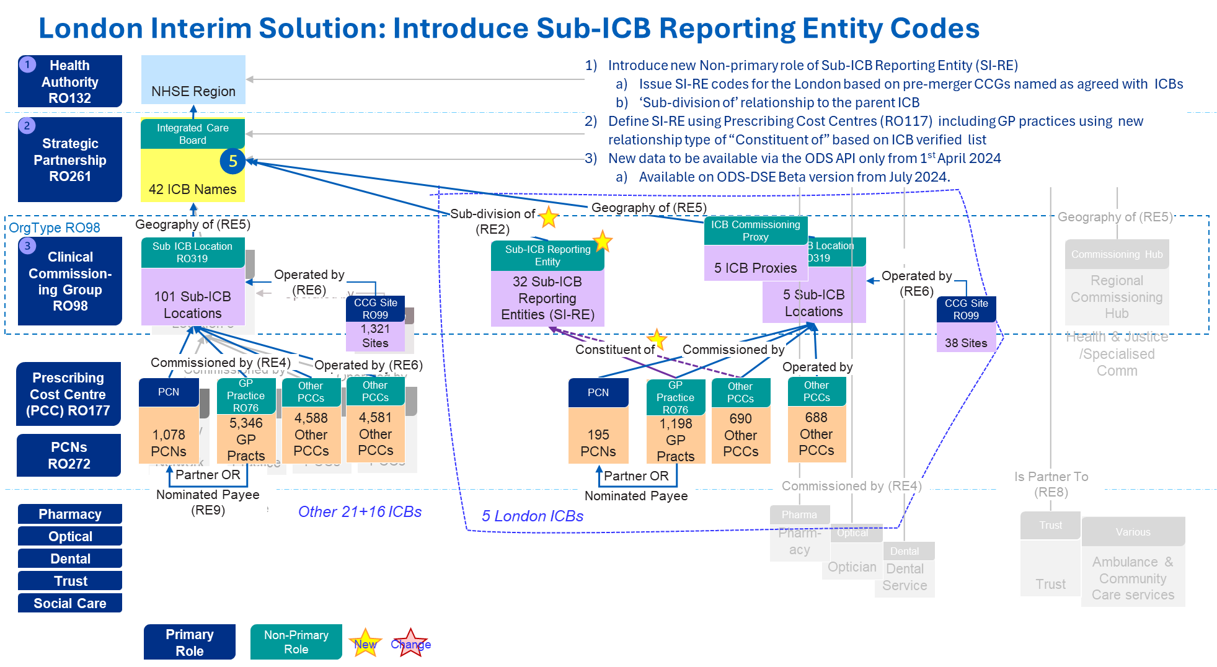

* 1. ****Summary View****

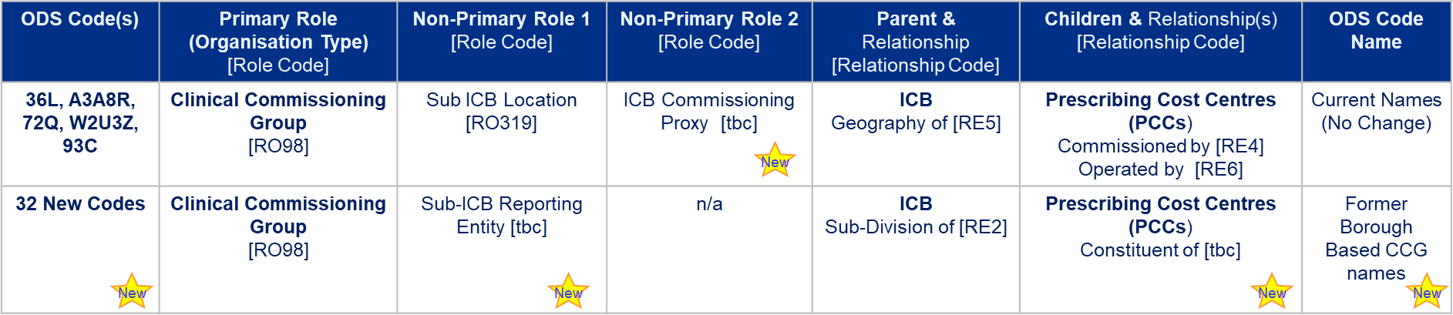

1. Note ODS issue Borough codes but these are not part of the NHS commissioning hierarchy of Region>ICB>sub-ICB; the former Borough aligned CCG codes reflected GP populations too.